Lab Practical #09:

Study Packet capture and header analysis by Wireshark (HTTP, TCP, UDP, IP, etc.)

**Practical Assignment #09:**

1. **Explain usage of Wireshark tool.**
2. **Packet capture and header analysis by Wireshark (HTTP, TCP, UDP, IP, etc.)**

**1. Usage of Wireshark Tools**

1. **Captures Network Traffic**
2. Wireshark records the data packets that travel over a network (like Wi-Fi or LAN).
3. It helps you see what is happening in real-time**.**
4. **Analyzes Packets**
5. Each packet (small unit of data) can be opened to check details like source, destination, protocol used, etc.
6. Useful for understanding how communication happens between devices.
7. **Troubleshooting Networks**
8. Helps find network issues like slow speed, connection drops, or misconfigured settings.
9. Shows errors or unusual patterns in the data flow.
10. **Supports Many Protocols**
11. Wireshark can understand and display hundreds of network protocols (HTTP, TCP, UDP, DNS, etc.).
12. Makes it easy to study how different applications communicate.
13. **Filtering and Searching**
14. Allows applying filters to focus only on the required data (e.g., only HTTP traffic or only packets from a specific IP).
15. **Packet capture and header analysis by Wireshark (HTTP, TCP, UDP, IP, etc.)**

Using Wireshark, we can capture packets and analyze their headers at different layers of the OSI model. Some examples of header analysis include:  
 **• IP Header:** Contains source IP, destination IP, version, header length, TTL, and protocol type. **• TCP Header:** Includes source port, destination port, sequence number, acknowledgment number, flags, and window size.  
**• UDP Header:** Contains source port, destination port, length, and checksum. **• HTTP Header:** Includes request type (GET/POST), URL, host, user-agent, cookies, and response codes.

1. **HTTP**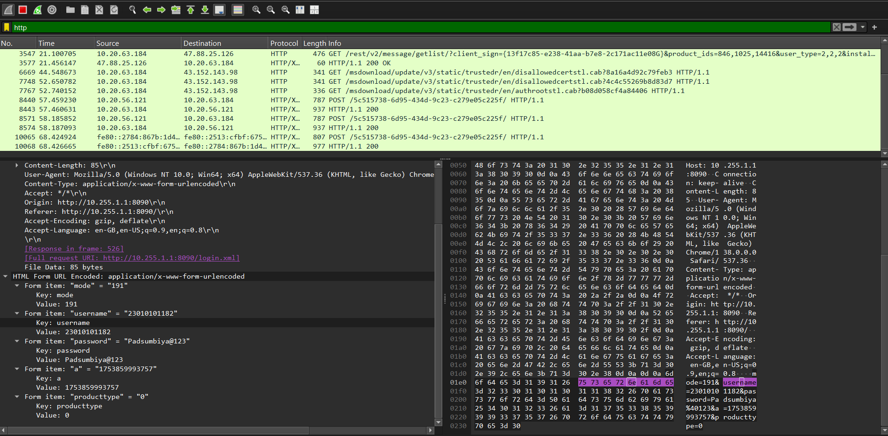

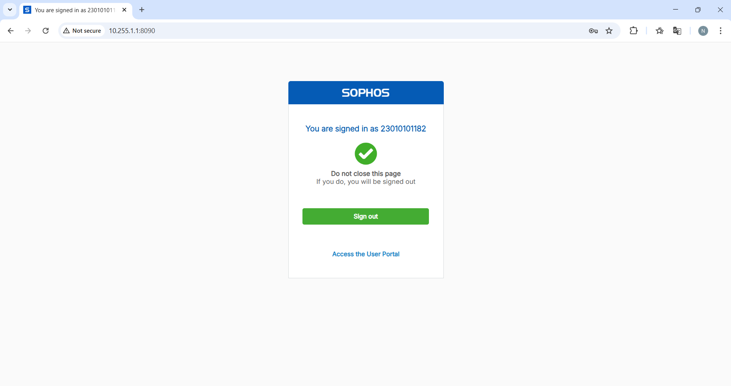

1. 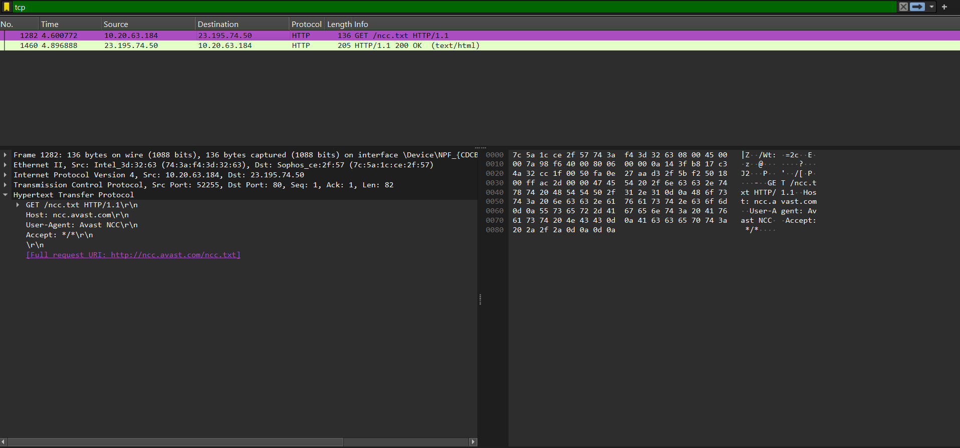**TCP**
2. 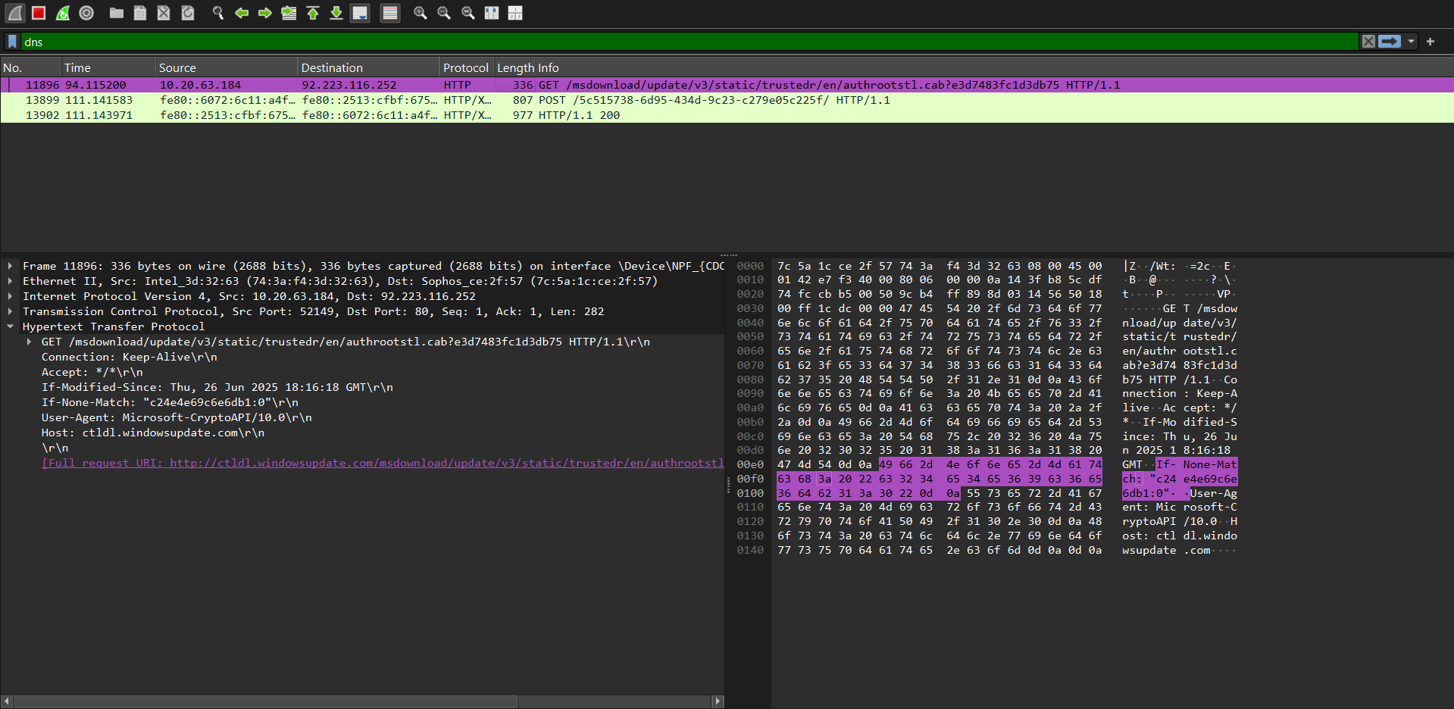**DNS**

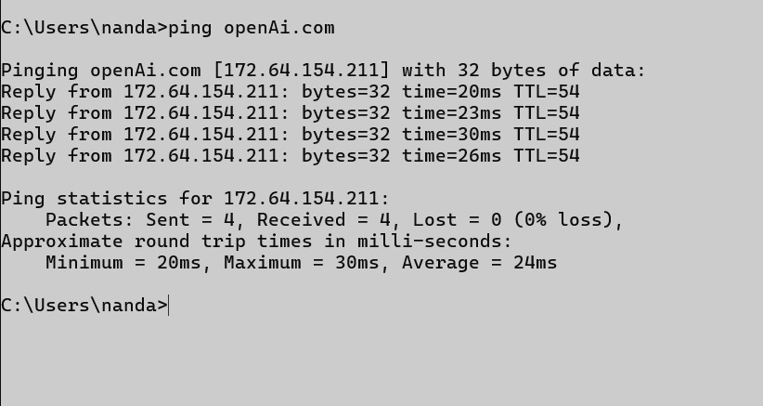

1. 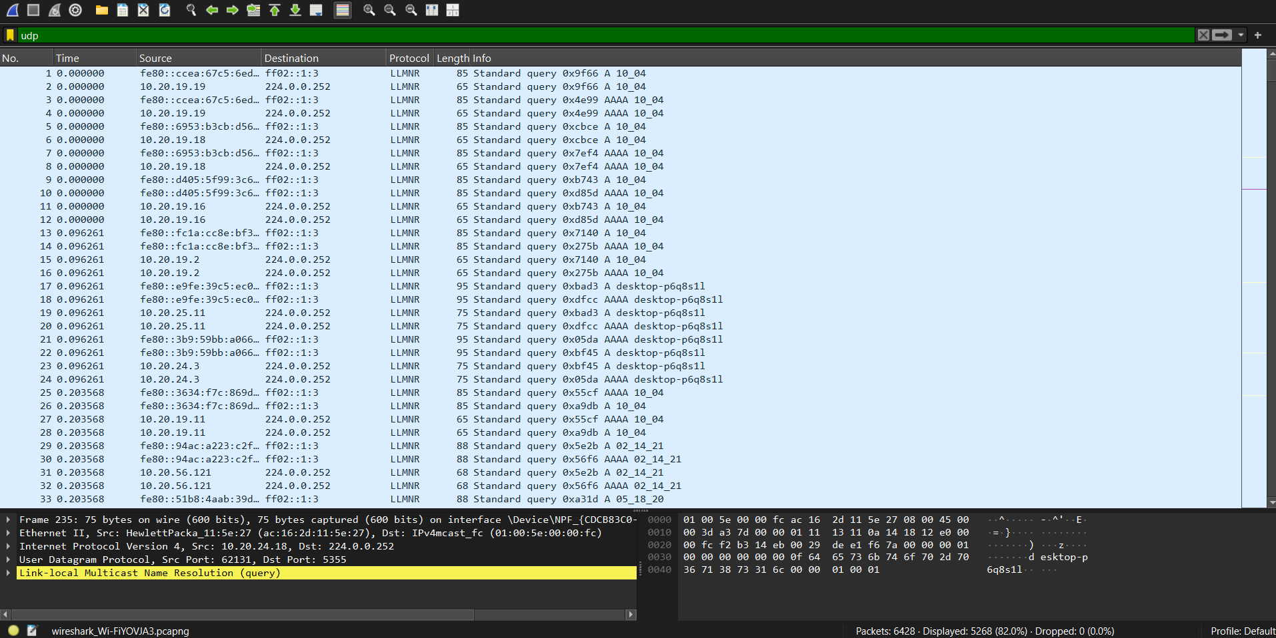**UDP**

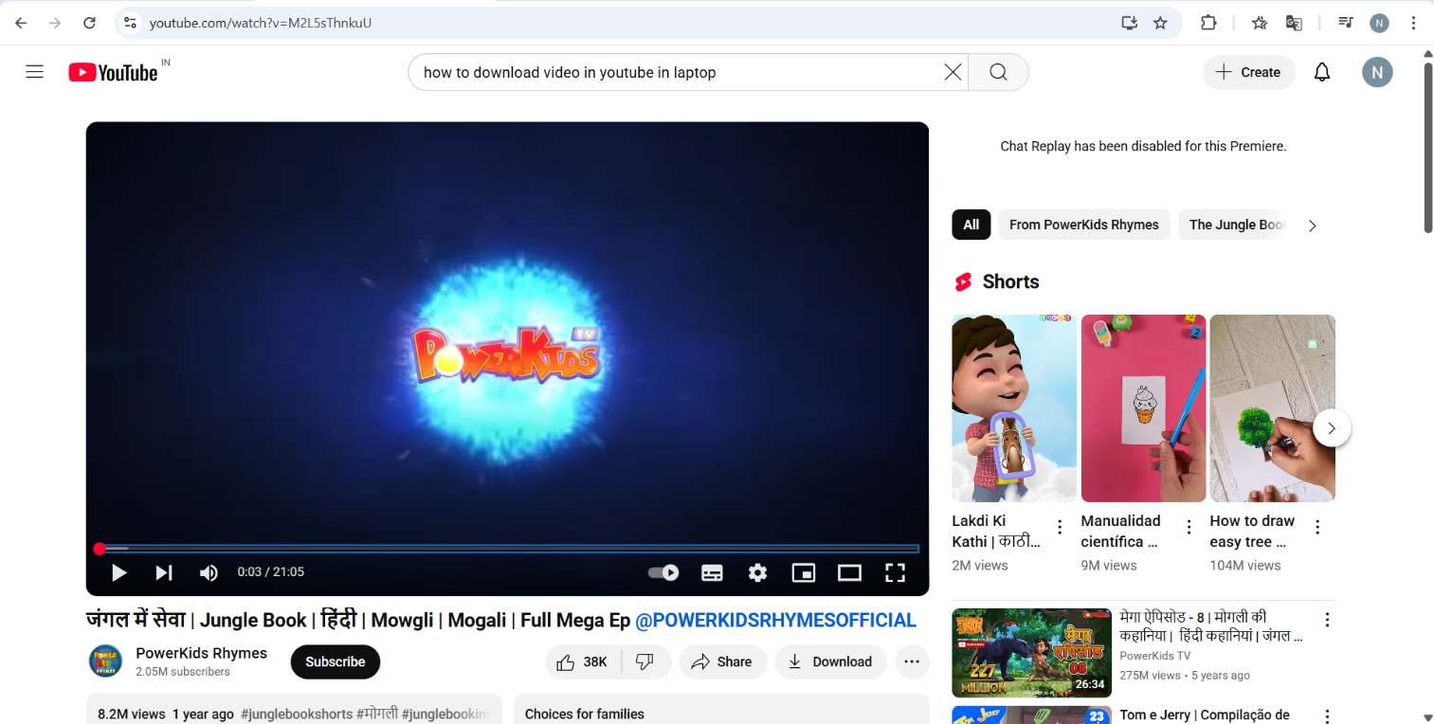

1. 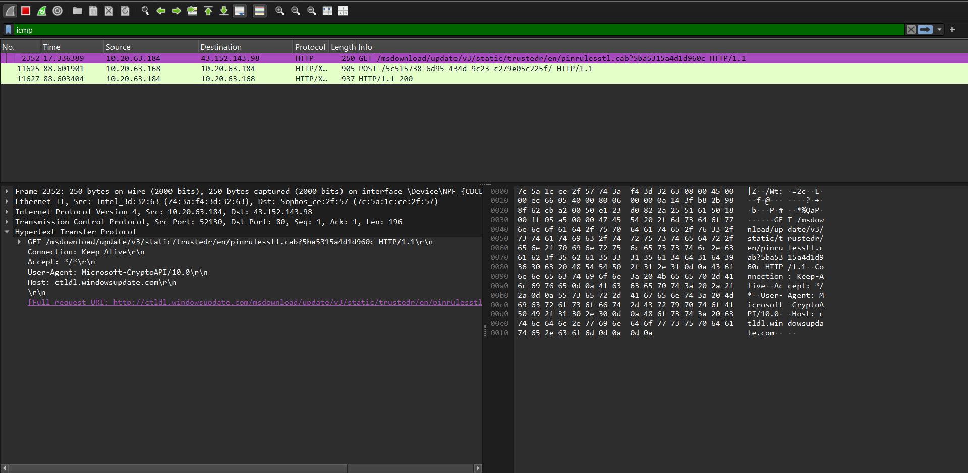**ICMP**

